Pectoral muscle segmentation on digital mammograms by Non Linear Diffusion Filtering

Authors

H.MIRZAALIAN, M.R. AHMADZADEH, S. SADRI

Published: 2007 IEEE Pacific Rim Conference on Communications, Computers and Signal Processing |Date: 22-24 Aug.2007|Page no.: 581-584

presented by:

abhijeet singh 1301CH01

aman prakash singh 1301EE02

Algorithm for the implementation:

Our original image is :

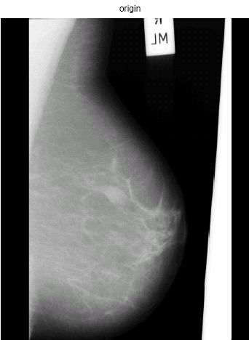

1. Pre-processing of image: we remove the label of the image, to do this we first calculate the intensity at the N3 spot as suggested, to determine whether it is a left breast or the right breast, after the determination of the side of the breast we start our iteration for checking the intensity from that side if it less than a particular value we start scanning the image and as soon as we get a high value of intensity we increment a counter by one, the we check when this intensity again falls to again particular value, and if the fallen intensity comes out to be continuous for certain specific number of pixels we check when this intensity again increases to a certain particular value you increment the counter and make the intensity of all the next pixels as zero. You apply a Gaussian filter on the image once in the pre-processing stage so that the algorithm does not confuse with the image boundary and the boundary of the pectoral muscle. After the removal of the tag the image looks like:

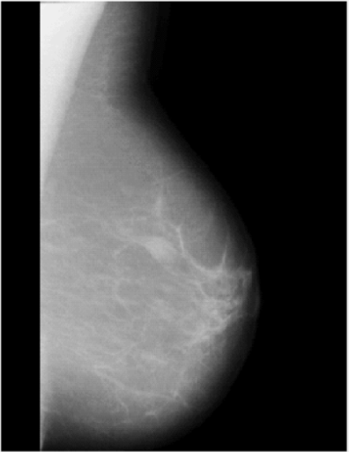

1. We select our ROI, various assumptions and calculations are done in calculating our ROI.
2. We run iteration 30 times and in each iteration :
3. We apply the Gaussian filter on an image
4. We find the gradient of the image
5. Use the gradient of the image and apply the non diffusion filter as suggested by the author on the gradient of each and every pixel, this operation is done through the loops which iterate all over our ROI.
6. To the non diffusion filter applied image, we calculate the divergence of the image
7. Use the divergence of the image calculated to update our ROI in every successful iteration
8. Do the global thresholding of the image with the given values
9. Plot the final contour of the image.

Final images of the every iteration are:

